**A**

**MINI PROJECT REPORT**

**ON**

**“ONLINE BLOOD BANK MANAGEMENT SYSTEM”**

**SUBMITTED TO**



**SAVITRIBAI PHULE PUNE UNIVERSITY, PUNE**

**FOR THE PARTIAL FULLFILLMENT OF THE DEGREE OF**

**MASTER OF COMPUTER APPLICATION (MCA)**

**SUBMITTED BY**

**DHORDE AISHWARYA PRAVIN**



**PIRENS INSTITUTE OF BUSINESS MANAGEMENT AND**

**ADMINISTRATION (IBMA)**

**LONI (BK), TAL- RAHATA, DIST.- AHMEDNAGAR.**

**SAVITRIBAI PHULE PUNE UNIVERSITY**

**2022-23**



**SAVITRIBAI PHULE PUNE UNIVERSITY, PUNE**

**CERTIFICATE**

This to certify that

**DHORDE AISHWARYA PRAVIN**

**Seat Number - 7015**

Student of Second Year of Master of Computer Application (MCA)

was examined in **Mini Project Report** entitled

**“ONLINE BLOOD BANK MANAGEMENT SYSTEM”**

On - / /2023

**AT**

**PIRENS INSTITUTE OF BUSINESS MANAGEMENT AND**

**ADMINISTRATION, (IBMA)**

**LONI(BK), TAL- RAHATA, DIST- AHMEDNAGAR.**

**(Internal Examiner) (External Examiner)**

**CERTIFICATE BY GUIDE**

This is to certify that **Miss. Dhorde Aishwarya Pravin** and has completed the project work under my guidance and supervision that I have verified the work for documentation, problem statement and result presented in the project work.

Place: Loni **(Prof. R.V. Kotkar)**

Date: / /23 PIRENS IBMA, Loni

**ACKNOWLEDGEMENT**

I wish to take opportunity to express our profound thanks & gratitude to all those who have directly or indirectly helped us in the completion of this project.

I am also extremely thankful grateful to our project guide **(Prof. R.V. Kotkar)** inspiration and constructive suggestions that helpful us in the preparation of this project. We also thanks to our **Academic Co-ordinator of MCA-II (Master of Computer Application** who have helped in successful completion and certification of the project.

**INDEX**

|  |  |  |  |
| --- | --- | --- | --- |
| Chapter  No |  | Details | Page No |
| 1 |  | INTRODUCTION |  |
|  | 1.1 | Company Profile |  |
|  | 1.2 | Abstract |  |
|  | 1.3 | Existing System And Need for System |  |
|  | 1.4 | Scope of System |  |
|  | 1.5 | Operating Environment- Hardware and Software |  |
|  | 1.6 | Brief Description of Technology Used  1.6.1 Operating System Used (windows or Unix)  1.6.2 RDBMS/No Sql used to build database. |  |
| 2 |  | PROPOSED SYSTEM |  |
|  | 2.1 | Study of Similar Systems |  |
|  | 2.2 | Feasibility Study |  |
|  | 2.3 | Objective of the proposed System |  |
|  | 2.4 | Users of System |  |
| 3 |  | ANALYSIS & DESIGN |  |
|  | 3.1 | Entity Relationship Diagram(ERD) |  |
|  | 3.2 | Table Diractory |  |
|  | 3.3 | Use Case Diagram |  |
|  | 3.4 | Class Diagram |  |
|  | 3.5 | Activity Diagram |  |
|  | 3.6 | Deployment Diagram |  |
|  | 3.7 | Sequence Diagram |  |
|  | 3.8 | Sample Input and Output Screens |  |
| 4 |  | Coding |  |
|  |  | code |  |
| 5 |  | Testing |  |
|  | 5.1 | Test Procedure |  |
|  | 5.2 | Test Plan  5.2.1 Unit Testing  5.2.2 Integration Testing  5.2.3 Security Testing  5.2.4 Regression Testing  5.2.5 Acceptance Testing  5.2.6 Beta Testing  5.2.7 Tools |  |
| 6 |  | Limitations of Proposed System |  |
| 7 |  | Conclusion |  |
| 8 |  | Bibliography |  |

**INTRODUCTION**

CHAPTER 1: INTRODUCTION

1.1 Company Profile

1.2 Project Introduction

1.3 Existing System and Need for System

1.4 Scope of Work

1.5 Operating Environment - Hardware and Software

1.6 Brief Description of Technology Used

1.6.1 Operating system Used

1.6.2 RDBMS/No Sql used to built database

Chapter 1

INTRODUCTION

The main aim of developing this system is to provide blood to the people who are in need of blood.

The number of persons who are in need of blood are increasing in large number day by day.

Using this system user can search blood group available in the city and he can also get contact number of the donor who has the same blood group he needs.

In order to help people who are in need of blood, this Online Blood Bank management system can be used effectively for getting the details of available blood groups and user can also get contact number of the blood donors having the same blood group and within the same city.

So if the blood group is not available in the blood bank user can request the donor to donate the blood to him and save someone life.

1.1 COMPANY PROFILE

About Us

TechnoKraft Training & Solution Pvt. Ltd. is proudly ‘krafting’ tech-skills of IT aspirants and students longing to build a career in the IT world. Based in the city of Nashik for the last 5 years, our core values are excellence, pursuing growth and quality learning, and delivering WOW with our excellent services. We might only be 5 years young, but we are better known to be wiser beyond our age, simply because of our exceptional learning process.

Our primary focus is to bridge the gap between the demand and supply of talented and diverse IT Professionals by serving significant education and solutions. Hundreds of students come out from our institute as rising stars, ready to rock their IT careers. We make them ready to face all the upcoming challenges of the professional world by giving them a 360-degree education.

We are known to strike a perfect balance between theoretical and practical learning. That is why we have been able to train and provide placement to more than 3000 students in such short years. We utterly believe in giving top-notch training and flawless service by not just maintaining but regularly upgrading our standards and versions!

Contact Us

TechnoKraft Training & solutions

1st Floor, Kanchwala Avenue,

Above Viju’s Dabeli, Thatte Nagar Marg , College Road Nasik

Contact : +91-253-2312447

Web : w.w.w.tts.net.in

Email : [info@tts.net,in](mailto:info@tts.net,in)

1.2 Abstract

The Blood Bank Management System (BBMS) is an application that stores, processes,

retrieves, and analyzes data about blood bank administration. It also supervises the blood inventory

management and other blood bank-related activities.

The major goal of the blood bank management system is to keep track of blood, donors, blood

groups, blood banks, and stock information. It keeps track of all information concerning blood,

blood cells, stocks, and blood. Because the project is all done at the administrative level, only the

administrator can see it."

The Blood Bank Management System (BBMS) is an application that stores, processes, retrieves, and analyzes data about blood bank administration. It also supervises blood inventory management and other blood bank-related activities.

The major goal of the blood bank management system is to keep track of blood, donors, blood groups, blood banks, and stock information. It keeps track of all information concerning blood, blood cells, stocks, and blood. Because the project is all done at the administrative level, only the administrator can see it.

The Blood Bank Management System (BBMS) is an application that stores, processes,

retrieves, and analyzes data about blood bank administration. It also supervises the blood inventory

management and other blood bank-related activities.

The major goal of the blood bank management system is to keep track of blood, donors, blood

groups, blood banks, and stock information. It keeps track of all information concerning blood,

blood cells, stocks, and blood. Because the project is all done at the administrative level, only the

administrator can see it."

1.3 Existing System and Need for System

In existing system the blood bank management system exhibited at a lot of ineffectiveness and inefficiency that had fetched impact taken by management. The system which was manual that is based on paper card to collect blood donor data, keep record of blood donors and disseminate results to blood donors, had weakness that needed IT based solutions. The system was characterized by delays and sometimes failure to access historical records;

**Need For System**

The need for a blood bank management system arises from several critical factors that impact the blood donation and transfusion process. Here are some key reasons why such a system is necessary:

**1.Efficient Blood Inventory Management:**

Blood banks deal with a perishable and life-saving product. An organized system is required to manage the blood inventory effectively, ensuring an adequate supply of different blood types while minimizing wastage and the risk of shortages.

**2.Quick Access to Blood Units during Emergencies:**

During emergencies, time is of the essence. A systematic approach ensures that healthcare providers can quickly find and access the required blood units for patients in critical conditions, saving lives.

**3.Donor Engagement and Retention:**

A blood bank management system can help engage donors by providing them with convenient online registration, appointment scheduling, and timely reminders. This encourages regular blood donations and enhances donor retention.

**4.Matching Blood Types:**

The system's ability to match donors with specific blood types to patients in need is essential for successful blood transfusions. Manual matching processes can be time-consuming and error-prone, which is why an automated system is necessary.

**5.Transparency and Accountability:**

The system promotes transparency in the blood donation and distribution process, ensuring that there is a clear record of all transactions. This fosters accountability among blood bank staff and stakeholders.

1.4 Scope of System

The scope of an online blood management system is broad and encompasses various aspects related to the efficient management of blood donations, inventory, and distribution. Here are the key areas that fall under the scope of such a system:

**1. Donor Management:**

User registration and profile management for donors, including personal information and blood type.

Allow donors to schedule appointments for blood donations and view their donation history.

Track donor eligibility criteria, donation frequency, and health status.

**2. Blood Inventory Management:**

Maintain a comprehensive database of available blood units, including blood type, quantity, and expiration date.

Automatic tracking of blood units, including their collection, testing, processing, and storage details.

Monitor inventory levels and send alerts for low stock or expiring units.

**3. Blood Donation Camps:**

Facilitate the organization and management of blood donation camps in collaboration with organizations and communities.

Allow donors to register for these camps and provide details about the camp locations and schedules.

**1.5 Operating Environment - Hardware and Software**

* To run this software system effectively and efficiently we will require the software like: -
* Windows Operating System
* Frontend – HTML, CSS
* Backend – PHP
* Database – MySQL
* Softwares – Visual Studio, Apache XAMPP,
* The hardware requirement to run this software system efficiently is as follows

A PC with 1GB RAM, 100 GB HDD

**MINIMUM HARDWARE REQUIREMENTS**

* Monitor
* Keyboard
* Processor > 2.0 Ghz
* RAM > 4Gb
* Internet Connection

**SOFTWARE REQUIREMENTS**

* Windows/Unix/Linux
* Ms-SQL
* Visual Studio 2019
* IIS Server
* Front end- Browser with support for C# and ASP

1.6 Brief Description of Technology Used

1.6.1 Operating Systems Used (Windows)

**All About Windows**

Windows is an operating system designed by Microsoft. The operatystem is what allows you to use a computer. Windows comes preloaded on most new personal computers (PCs), which helps to make it the most popular operating system in the world.Windows makes it possible to complete all types of everyday tasks on your computer. For example, you can use Windows to browse the Internet, check your email, edit digital photos, listen to music, play games, and do much more.

Including how to use the desktop, how to open different files and applications, and how to move and resize windows. The information in this tutorial will apply to more recent versions of Windows, including the ones mentioned above. However, once you've learned the basics, you may also want to review one of our **version-specific** **Windows tutorials**. Just select the version of Windows that's installed on your computer:

[Windows 10](http://www.gcflearnfree.org/windows10)

[Windows 8](http://www.gcflearnfree.org/windows8)

[Windows 7](http://www.gcflearnfree.org/windows7)

[Windows XP](http://www.gcflearnfree.org/windowsxp)

**Windows 8 vs. other versions**

While most versions of Windows are relatively similar, Windows 8 works very differently from other versions. However, if you have Windows 8 on your computer, you should now be able to upgrade to Windows 10, which is more similar to earlier versions, including Windows 7. We recommend upgrading your computer to Windows 10 if you can.

However, we'll still point out any major differences between Windows 8 and other versions, which means you'll see some Windows 8-specific information from time to time. If your computer uses Windows 8, you'll want to review both this tutorial and our [Windows 8](http://www.gcflearnfree.org/windows8) tutorial to learn more about the differences.

**NavigatingWindows**

Whether you're new to computers or just Windows, it's important to learn the basics of using your computer. If it all seems a little overwhelming right now, don't worry! We'll take you through itstep by step and show you some of the most fundamental things you'll need to know, including how to work with the desktop**,**open and close windows, andturn off your computer**.**

**The desktop**

Once your computer has finished starting up, the first thing you'll see is the desktop. You can think of the desktop as the main workspace for your computer. From here, you can view and manage your files, open applications, access the Internet, and much more.

**Working with windows**

Whenever you open a file, folder, or application, it will appear in a new window. You can have multiple items open at the same time in different windows. You'll use windows all the time, so it's important to know how to switch between open windows, how to move and resize windows, and how to close windows when you're done using them.

In Windows 8, some programs will open on the Start screen, not the desktop. If you're using Windows 8, note that the information below applies only to windows you have opened on the desktop.

**Switching between windows**

If you have more than one window open at the same time, you can quickly switch between them by clicking the icon for that window on the taskbar.

**Shutting down your computer**

When you're done using your computer, it's important to shut it down properly. The procedure will vary slightly depending on which version of Windows you're using.

**To shut down your computer:**

* If you're using Windows 10, click the Start button, then the Power icon, then click shut down.
* If you're using Windows 8, click the Start button to access the Start screen, click the Power icon near the upper-right corner, and select shut down. If you don't see this option, it means you'll need to upgrade to Windows 8.1. Review [this page](http://www.gcflearnfree.org/windows8/windows-81-features/1/) from our Windows 8 tutorial to learn how.
* If you're using Windows 7 or earlier, click the Start button, then select shut down.

**Restarting and Sleep mode**

You can also click the power button button for more options. For example, if your computer has become unresponsive, you can choose Restart to quickly turn it off and on again.

You can also choose to put your computer into Sleep mode. This turns off most of your computer's processes, but it remembers which applications and files are open. It allows the computer to start up more quickly because you won't have to wait for the operating system and applications to load. Note that your computer may go into Sleep mode automatically if you haven't used it for more than a few minutes.

If you have a laptop, you can simply close the lid to put it into Sleep mode.

**Waking your computer from Sleep mode**

If your computer is in Sleep mode, you'll need to wake it to use it. To wake the computer from Sleep mode, click the mouse or press any key on the keyboard.

**1.6.2 RDBMS/No Sql used to build data base (mysql/oracle)**

* **MsSQL is a database management system.**

**Microsoft SQL Server** is a proprietary [relational database management system](https://en.wikipedia.org/wiki/Relational_database_management_system) developed by [Microsoft](https://en.wikipedia.org/wiki/Microsoft). As a [database server](https://en.wikipedia.org/wiki/Database_server), it is a [software product](https://en.wikipedia.org/wiki/Software_product) with the primary function of storing and retrieving data as requested by other [software applications](https://en.wikipedia.org/wiki/Software_application)—which may run either on the same computer or on another computer across a network (including the Internet). Microsoft markets at least a dozen different editions of Microsoft SQL Server, aimed at different audiences and for workloads ranging from small single-machine applications to large Internet-facing applications with many [concurrent users](https://en.wikipedia.org/wiki/Concurrent_user).

**MsSQL databases are relational*.***

MsSQL is a relational database management system

The database structure is organized into physical files optimized for speed. The logical data model, with objects such as data tables, views, rows, and columns, offers a flexible programming environment. Microsoft SQL Server is a relational database management system (RDBMS) that supports a wide variety of transaction processing, business intelligence and analytics applications in corporate IT environments. Microsoft SQL Server is one of the three market-leading database technologies, along with Oracle Database and IBM's [DB2](https://www.techtarget.com/searchdatacenter/definition/DB2).

Like other [RDBMS](https://www.techtarget.com/searchdatamanagement/definition/RDBMS-relational-database-management-system) software, Microsoft SQL Server is built on top of [SQL](https://searchsqlserver.techtarget.com/definition/SQL), a standardized programming language that database administrators ([DBAs](https://searchsqlserver.techtarget.com/definition/database-administrator)) and other IT professionals use to manage databases and query the data they contain. SQL Server is tied to Transact-SQL ([T-SQL](https://searchsqlserver.techtarget.com/definition/T-SQL)), an implementation of SQL from Microsoft that adds a set of proprietary programming extensions to the standard language

* **Ms-Sql software is Open Source.**

MySQL is an open-source database system so you can get support from its open-source community whereas SQL is not an open-source language rather you need to rely on your respective product vendor to support you during any issue.

* **The MySQL Database Server is very fast, reliable, scalable, and easy to use.**

SQL Server 2017 is the fastest database everywhere you need it. Whether it is your laptop, in your private cloud, or in our Azure public cloud infrastructure. Whether it is running on Linux, Windows, or Docker Containers, we have the speed to power any workload your application needs. Scalability is the ability to expand or contract the capacity of system resources in order to support the changing usage of your application. This can refer both to increasing and decreasing usage of the application. The main reason relational databases cannot scale horizontally is due to the flexibility of the query syntax. SQL allows you to add all sorts of conditions and filters on your data such that it's impossible for the database system to know which pieces of your data will be fetched until your query is executed.

Generally speaking, SQL is an easy language to learn. If you understand programming and already know some other languages, you can learn SQL in a few weeks. If you're a beginner, completely new to programming, it can take longer.

**PROPOSED SYSTEM**

**CHAPTER 2: PROPOSED SYSTEM**

2.1 Proposed System

2.2 Feasibility Study

2.3 Objective of Proposed System

2.4 Advantages of System

**2.1 Proposed System**

The proposed Blood Bank Management System helps the Blood Bank Admin to easily monitor the blood requests and users database.

The proposed system takes a systematic approach of how to bridge the gap between Recipients, Donors, and Blood Banks.

It improves the existing system by providing a common ground to ease the process of blood donation and reception.

The Blood Bank admin uses Donors Registered Phone Number and Email-Id to verify the request so as to confirm the booking.

While requesting the blood, the registered recipient can also check the availability of the required blood type as displayed by the admin.

A direct messaging feature for inquiries is also available to the registered user.

**2.2 Feasibility Study**

Feasibility study is a process to check possibilities of system development. It is a method to check various different requirements and availability of financial & technical resources. Before starting the process various parameters must be checked like: • Estimated finance is there or not? • The man power to operate the system is there or not? • The man power is trained or not? There are three different ways feasibility can be tested

1) Economical Feasibility

2) Technical Feasibility

3) Operational Feasibility.

**2.2.1 Economical Feasibility:**

This is very important aspect to be considered while developing project .we decided the technology based on minimum possible cost factor.

All hardware and software cost has to be born by the organization.

Overall we have estimated that the benefits the organization is going to receive from the proposed system will surely overcome the initial costs and the later on running cost for system.

**2.2.2 Technical Feasibility:**

It is basically used to see existing computer, hardware and software etc., weather it is sufficient or additional equipment are required? Minimum System Requirement is such that it can be affordable by of the user who is having computer. All the user requires is compatible browser and .net framework installed so our system is fully technical feasible.

**2.2.3 Operational Feasibility:**

Once the system is designed there must be trained and expert operator. If there are not trained they should given training according to the needs of the system. From the user’s perspective our system fully operational feasible as it just requires some knowledge of computer. Operators only need add daily prices of various equities and there are enough validations available so operator does not require any special technical knowledge. So our system also passes the test of operational feasibility.

**2.3 Objective of The System**

The proposed Blood Bank management system helps the people who are in need of a blood by giving them all details of blood group availability or regarding the donors with the same blood group.

Our website work 24x7 so user can get information of blood donor any time. Blood donor can also get registered and save life of other person.

**2.4 Advantages of System**

* Increased access to blood donors: An online blood bank management system can expand the donor pool by making it easier for people to register and donate blood. This can help to address shortages and ensure that there is an adequate supply of blood for patients in need.
* Faster response times: With an online system, blood banks can quickly match donors with recipients based on their blood type and other relevant factors, reducing the time it takes to provide life-saving transfusions.
* Improved inventory management: Online systems can provide real-time visibility into blood inventory levels, making it easier for blood banks to manage their supplies and avoid shortages.
* Better communication: An online system can facilitate communication between donors, recipients, and blood banks, making it easier to coordinate donations, arrange appointments, and provide updates on the status of blood supplies.
* Enhanced security and privacy: By implementing secure systems and protocols, an online blood bank management system can protect sensitive medical information and ensure that patient privacy is maintained.
* Cost-effective: An online blood bank management system can be cost-effective compared to traditional methods of blood management, as it can reduce the need for manual record-keeping, streamline processes, and minimize waste.

**ANALYSIS AND DESIGN**

**CHAPTER 3: ANLYSIS AND DESIGN**

3.1 ER- Diagram

3.2 Table Diractory

3.3 Use Case Diagram

3.4 Class Diagram

3.5 Activity Diagram

3.6 Component Diagram

3.7 Deployment Diagram

# 3.11 Sequence Diagram

# ERD-Diagram:

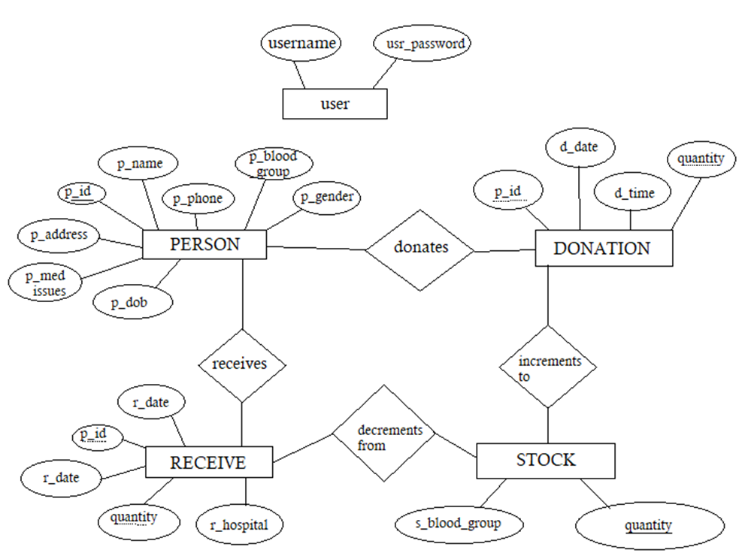

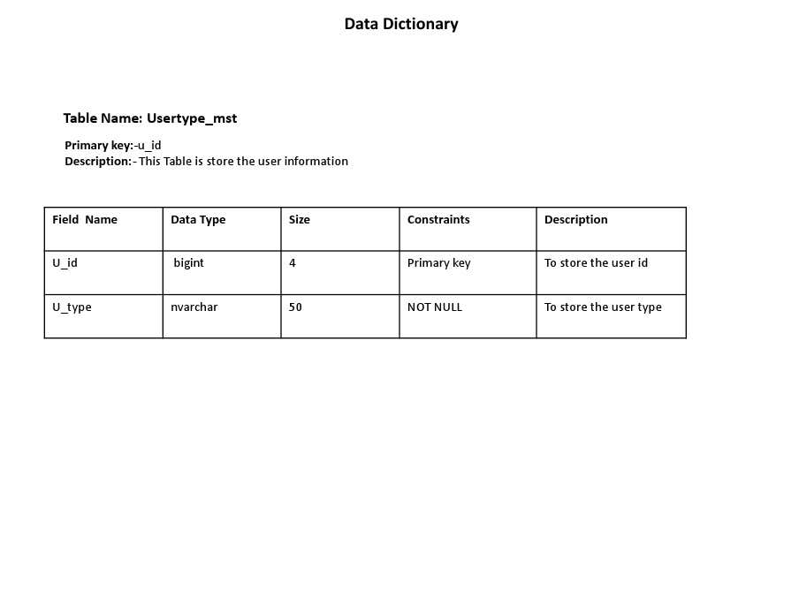

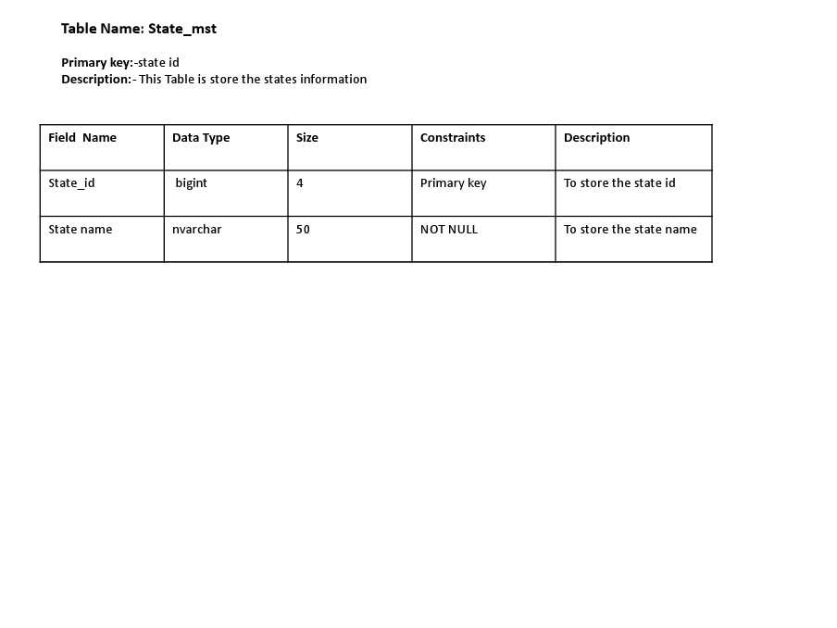

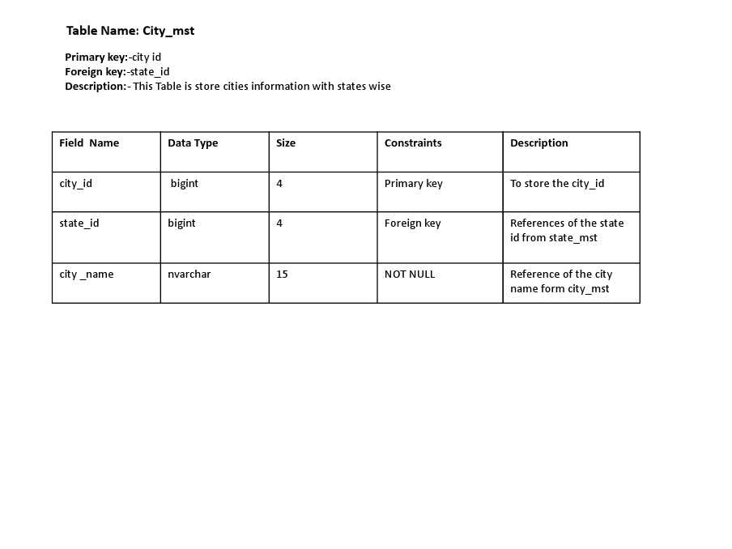

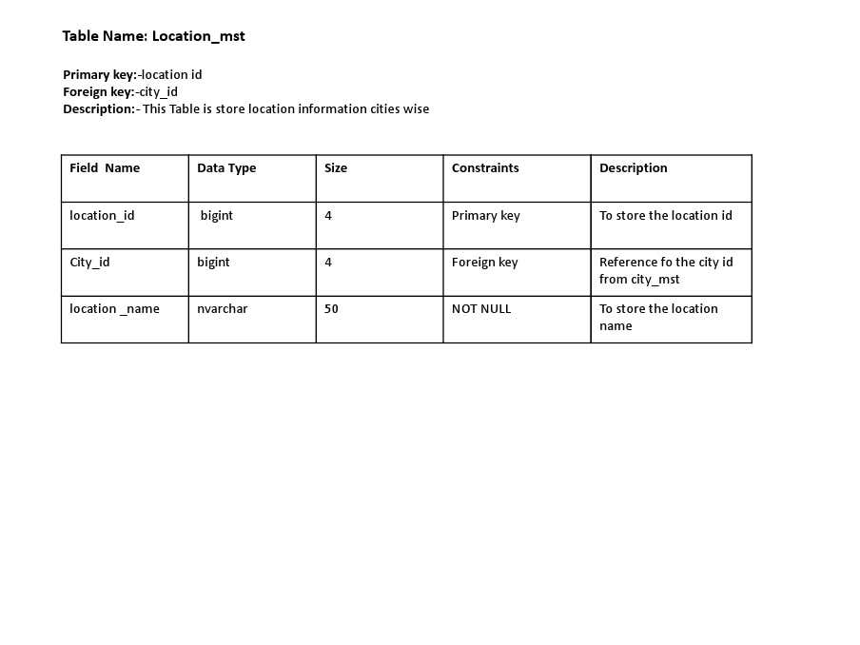

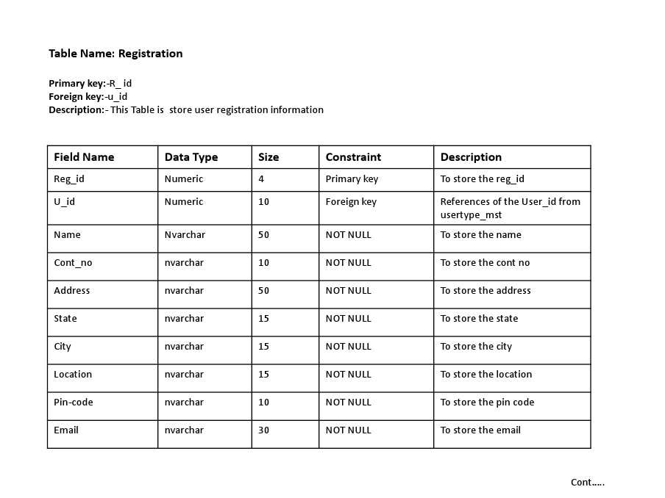

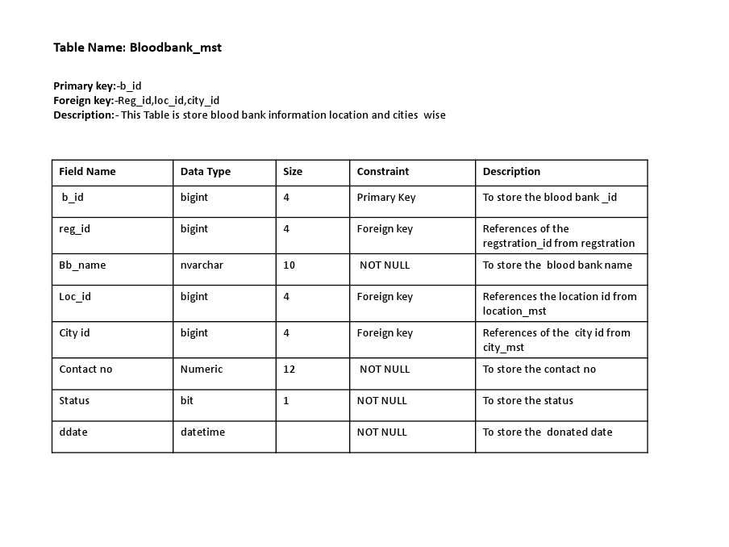

# Use Case Diagram

# https://html.scribdassets.com/7k36obsbsw5pxnqx/images/16-34f28e8e6e.jpghttps://html.scribdassets.com/7k36obsbsw5pxnqx/images/17-ee90f9e4b0.jpghttps://html.scribdassets.com/7k36obsbsw5pxnqx/images/18-6872c7170a.jpg

**Class Diagram**

**Blood Type**

#id: int

+bloodtype: string

**Donor**

# 

#id: int

+name: string

+satus: string

+bloodtype: string

+donorcard: int

# 

+request:string

**Recepients**

+ add()

**Processing**

# 

+verify()

**Donar Card**

**Blood Bank**

#id: int

+Ownername: string

+dontiondate: string

+details: string

#id: int

+name: string

+details: string

+address: text

+contactnumber: string

+add()

+verification()

+processRequest()

+validateTransaction()

**Blood Request**

#id: int

+name: string

+details: string

+date: string

+add()

**Activity Diagram**

**Start**

**Admin is Registered**

**Admin Login ID and Password**

**Check login id Password**

**Invalid Login/**

**Password**

**Login to the system Successfully**

**Set Userlevel and Permissions**

**Acess the Internal Functionalities Accoording to permission**

# End

**Deployment Diagram**



**Users Device**

(Donor/Recepient)

**Front-End Interface**

**Blood Records**

**Account Acess**

**System Dashboard**

**Server**

(System and Database Hosting)

Hosting)

**Admin Service**

**System Back-End**

# 

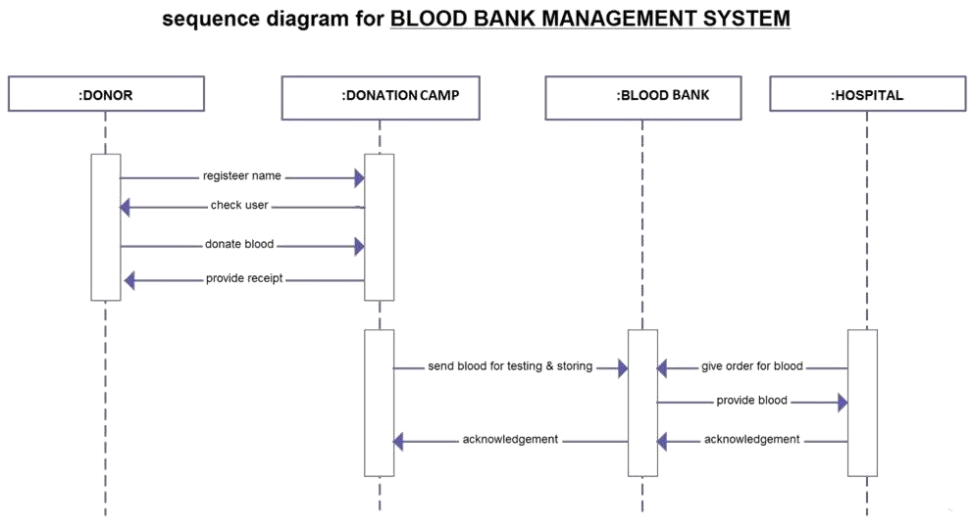

* 1. ample Input and Output Screens

1. **Home Login Screen**

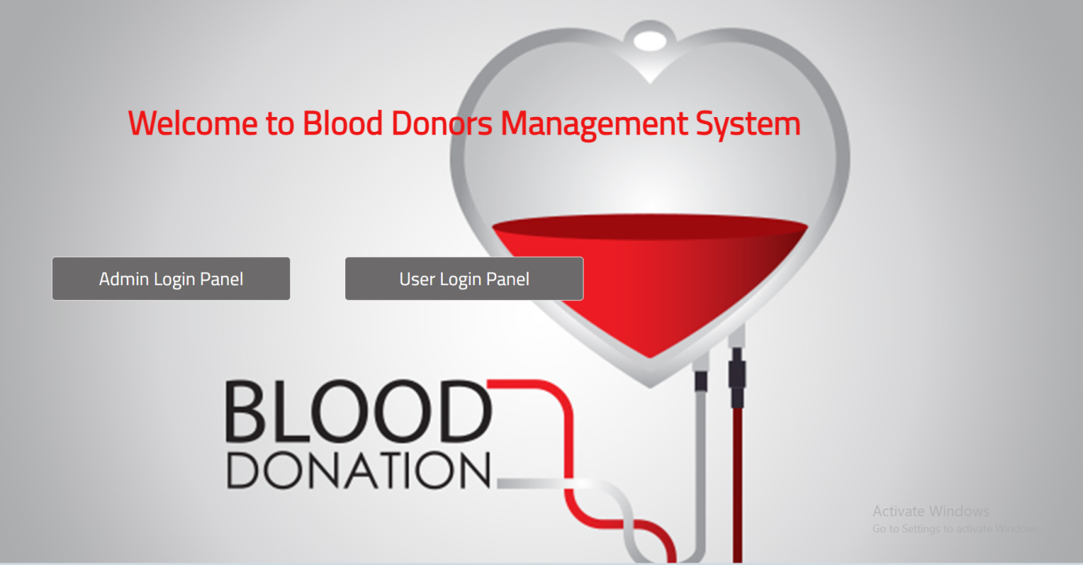

**This is a main page of blood management systems. There are two login Panel they are:**

1.Admin Login Panel

2.User Login Panel

1. **Registration Page**

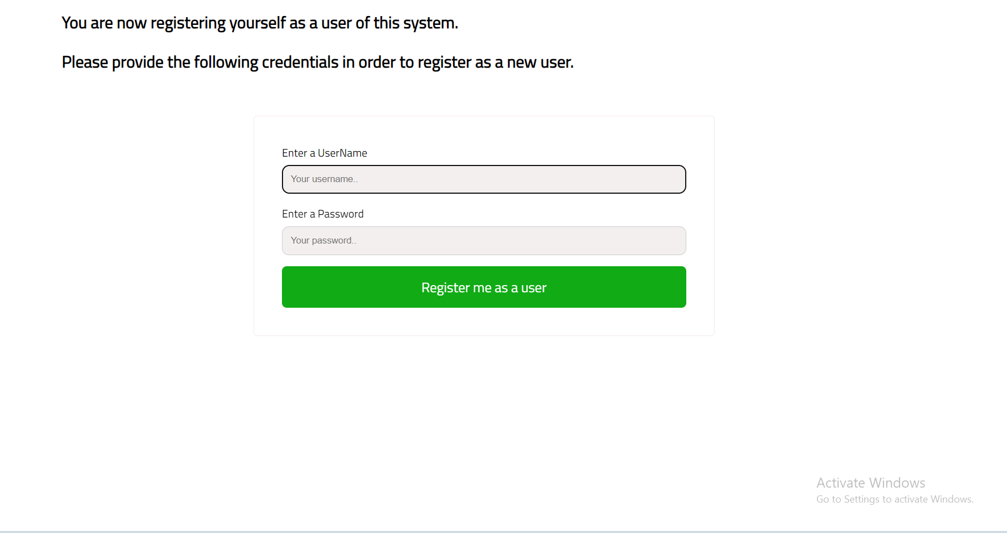

**This page is used to create new user page or registration page i.e user can register on this page**

**3 . login page or register**

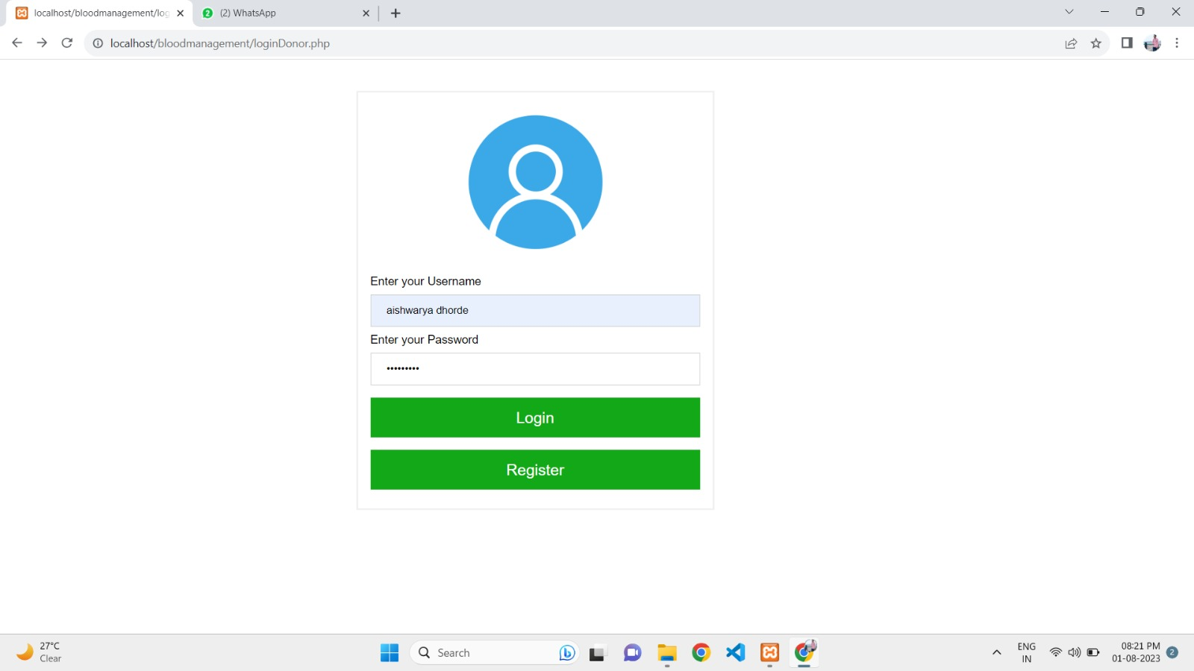

# This page is login page or register page. i.e. user can login or register on this page.

**4.Enter Information of Donors**

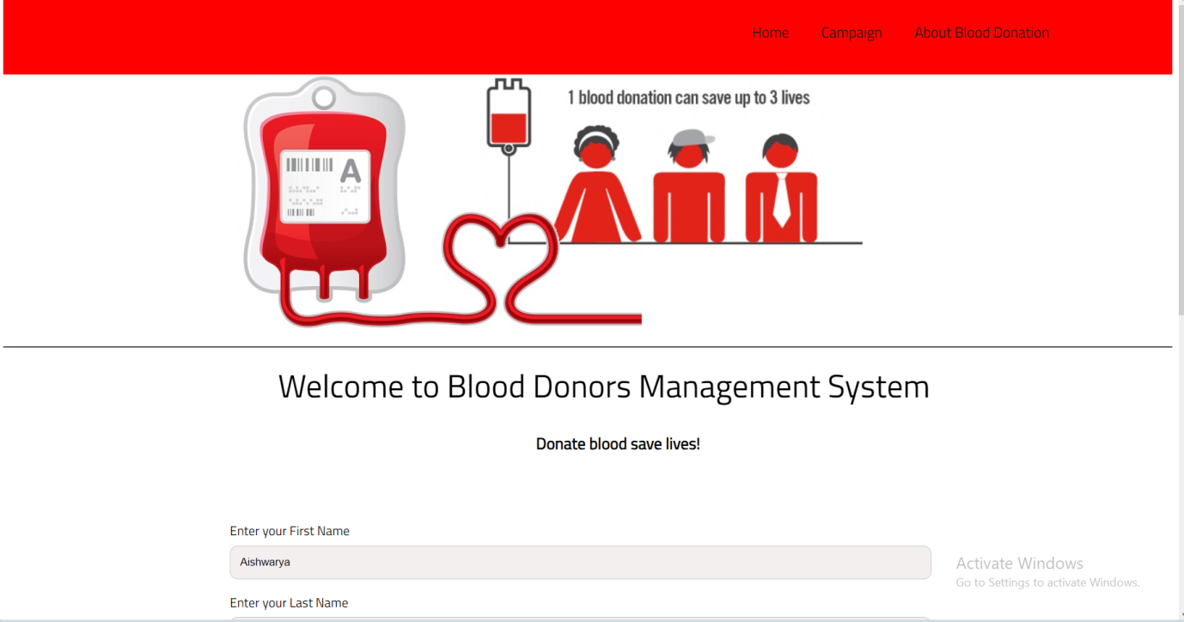

**This page Enter the Information of donors.This is show the Home page, Campaign, and About Blood Donation**

**5. Message Display Screen**

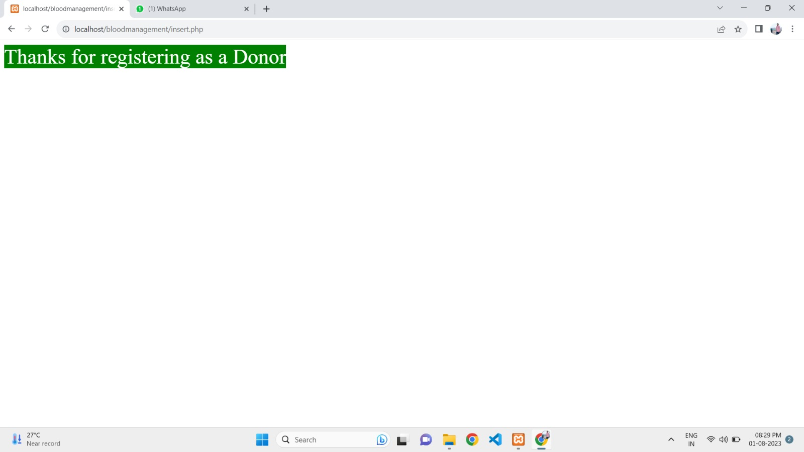

**This page showes the Registration is Done Sucessfully.**

**6. Campaign Page**

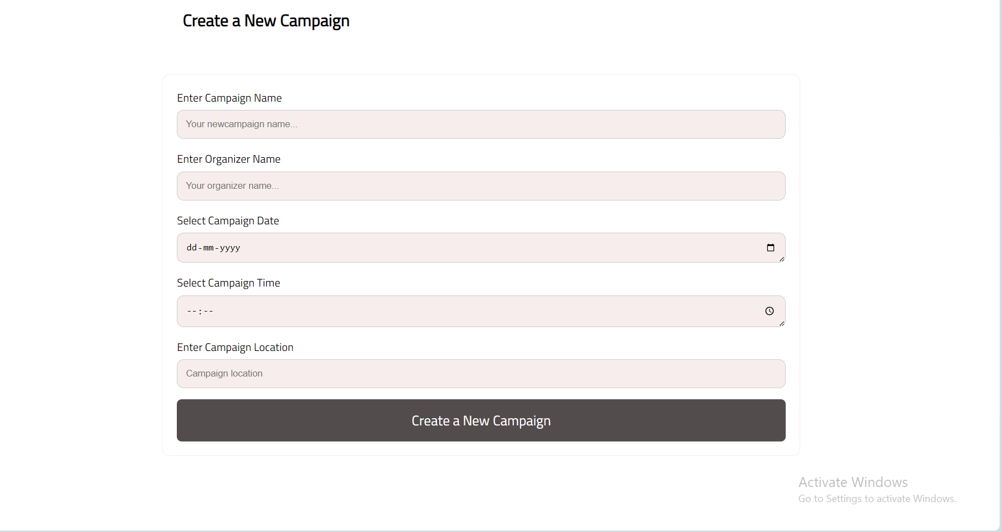

**This Camping Page to create and add the Information.**

**7. List of Campigns**

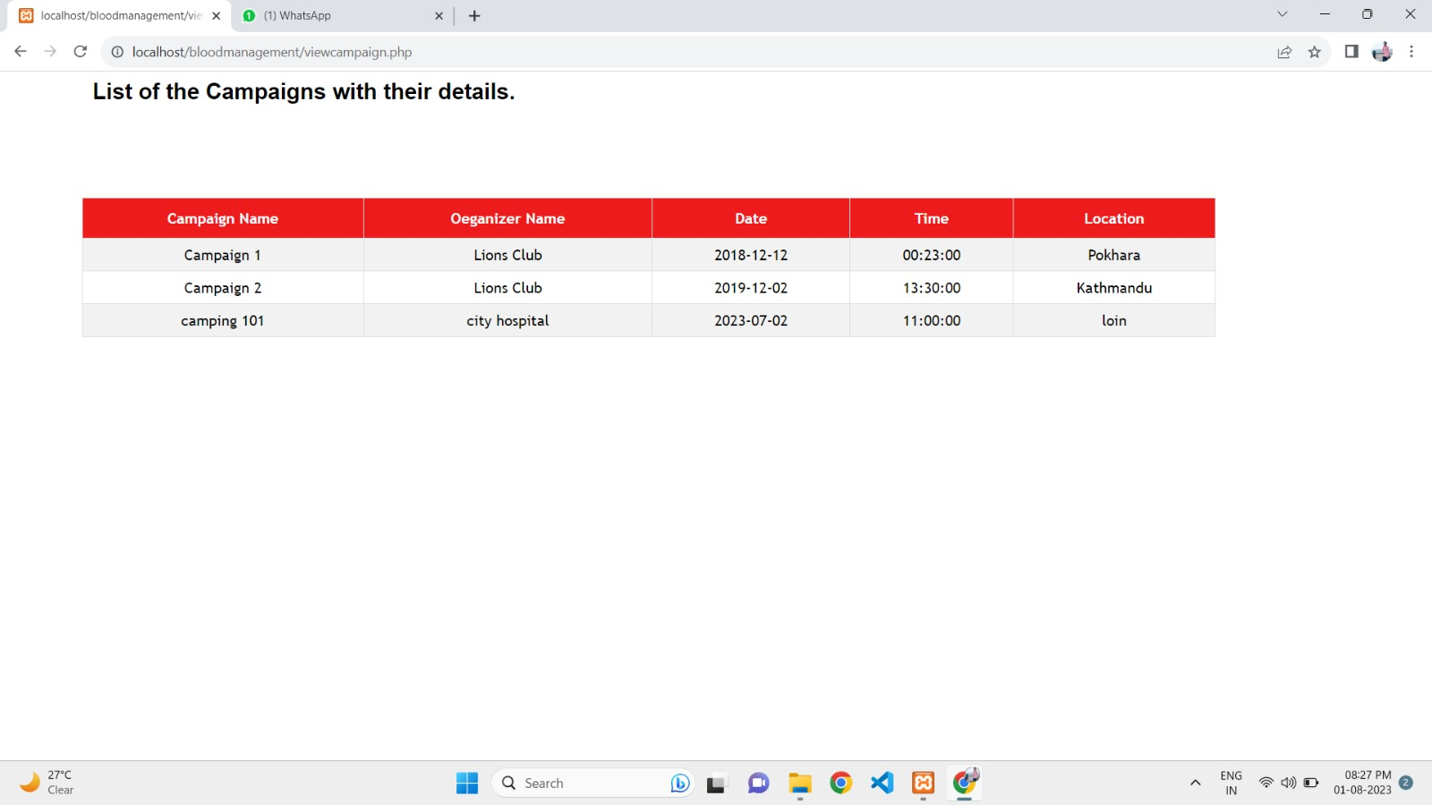

**This page show the list of campaigns with details**

**8. Admin Page**

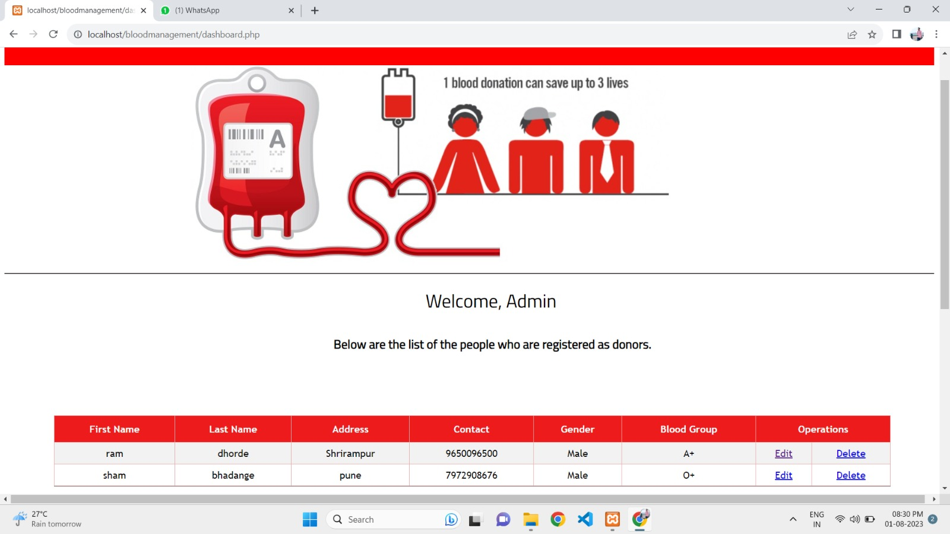

**This Page showes the list of donors and infrormation**

**9. Donar Information Saves**

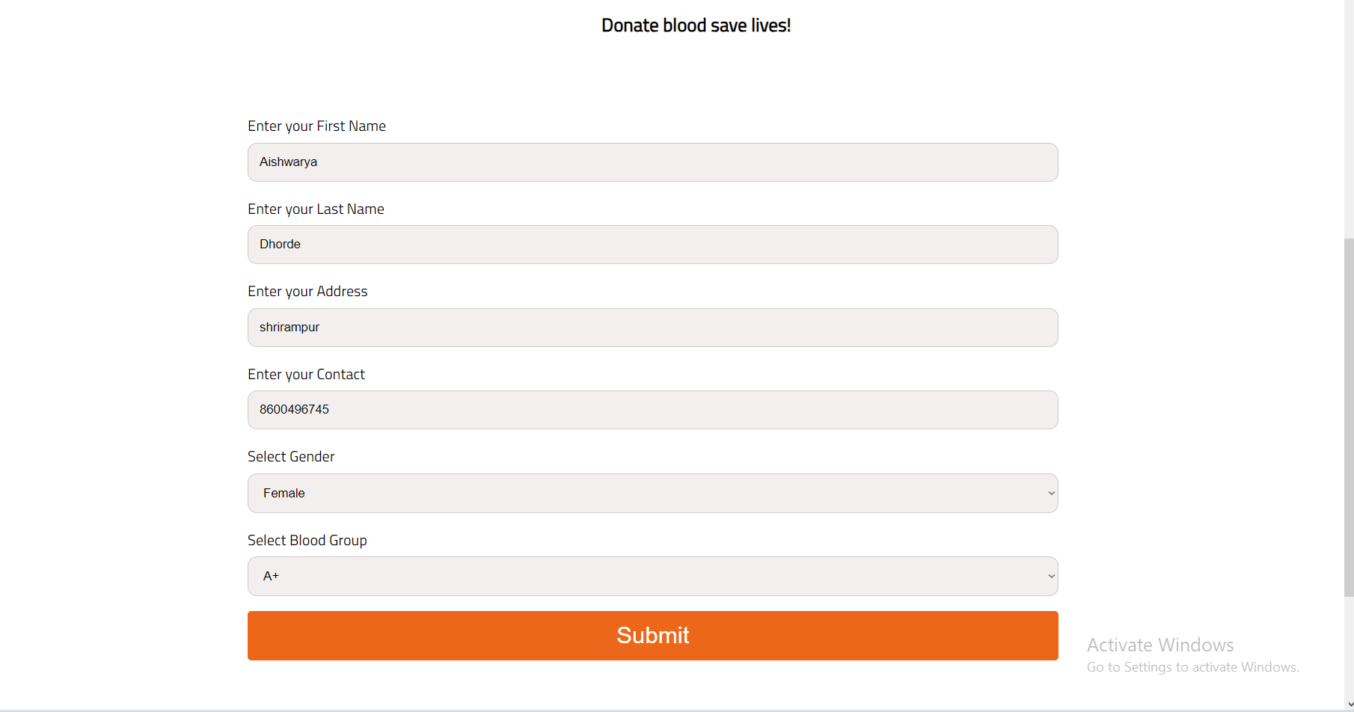

**This pages shows the who donate blood there information add to this page.**

**4. SAMPLE PROGRAM CODE**

**ASP Code:**

1. **HomePageLogin**

<?php

//session_start(); //start a new or resume a existing session

//unset($_SESSION['key]']); //session closed

?>

<html>

</head>

<style>

form {

border: 3px solid #f1f1f1;

width:30%;

margin-left:450px;

margin-top:40px;

}

/* Full-width inputs */

input[type=text], input[type=password] {

width: 100%;

padding: 12px 20px;

margin: 8px 0;

display: inline-block;

border: 1px solid #ccc;

box-sizing: border-box;

}

input[type=password]:hover{

transition: 0.1s ease-in;

background-color: #F7F7F7;

}

input[type=text]:hover{

transition: 0.1s ease-in;

background-color: #F7F7F7;

}

/* Set a style for all buttons */

button {

background-color: #13A818;

color: white;

padding: 14px 20px;

margin: 8px 0;

border: none;

cursor: pointer;

width: 100%;

font-size: 20px;

}

/* Add a hover effect for buttons */

button:hover {

background-color:#06930B;

font-family: Helvetica;

}

input[type=register]{

background-color: #2CDED2;

color: white;

padding: 14px 20px;

margin: 8px 0;

border: none;

cursor: pointer;

width: 100%;

font-size: 20px;

}

/* Add a hover effect for buttons */

input[type=register]:hover {

background-color:#18B3A9;

font-family: Helvetica;

}

label{

font-size: 15px;

font-family: Helvetica;

}

/* Extra style for the cancel button (red) */

.cancelbtn {

width: auto;

padding: 10px 18px;

background-color: #f44336;

}

/* Center the avatar image inside this container */

.imgcontainer {

text-align: center;

margin: 24px 0 12px 0;

}

/* Avatar image */

img.avatar {

width: 40%;

border-radius: 50%;

}

/* Add padding to containers */

.container {

padding: 16px;

}

/* The "Forgot password" text */

span.psw {

float: right;

padding-top: 16px;

}

/* Change styles for span and cancel button on extra small screens */

@media screen and (max-width: 300px) {

span.psw {

display: block;

float: none;

}

.cancelbtn {

width: 100%;

}

}

</style>

</head>

<body>

<form action="successdonor.php" method="post">

<div class="imgcontainer">

<img src="images/user.png" alt="Avatar" class="avatar">

</div>

<div class="container">

<label for="uname">Enter your Username</label>

<input type="text" name="uname">

<label for="psw">Enter your Password</label>

<input type="password" name="psw">

<button type="submit">Login</button>

<button type="submit" formaction="register.html">Register</button>

</form>

</body>

</html>

**2.UserRegister**

<?php

if(isset($_POST['fname'])){

$fname=$_POST['fname'];

$lname=$_POST['lname'];

$address=$_POST['address'];

$contact=$_POST['contact'];

$gender=$_POST['gender'];

$blood=$_POST['blood'];

$servername="localhost";

$username="root";

$password="";

$dbname="blood_management_system";

$conn=mysqli_connect($servername,$username,$password,$dbname);

if(!$conn){

die("Error while connecting...");

}

$qry="insert into blood(fname,lname,address,contact,gender,blood_group) values ('$fname','$lname','$address','$contact','$gender','$blood')";

$result=mysqli_query($conn,$qry);

if($result){

echo"<span style='font-size:40px;background-color:green;color:white;'>Thanks for registering as a Donor</span>";

}

else{

echo"Error while inserting data";

}

}

else{

echo"Go back to registration page";

}

?>

<?php

if(isset($_POST['uname'])){

$uname=$_POST['uname'];

$pass=$_POST['pass'];

$servername="localhost";

$username="root";

$password="";

$dbname="blood_management_system";

$conn=mysqli_connect($servername,$username,$password,$dbname);

if(!$conn){

die("Error while connecting...");

}

$qry="insert into user(u_name,u_pass) values ('$uname','$pass')";

$result=mysqli_query($conn,$qry);

if($result){

echo"Sucessfully registered as a User";

header('location:registersuccess.html');

}

else{

echo"Error while registering as a donor";

}

}

else{

echo"Go back to registration page";

}

?>

**LoginPhpPage :**

<?php

?>

<html>

</head>

<style>

form {

border: 3px solid #f1f1f1;

width:30%;

margin-left:450px;

margin-top:40px;

}

input[type=text], input[type=password] {

width: 100%;

padding: 12px 20px;

margin: 8px 0;

display: inline-block;

border: 1px solid #ccc;

box-sizing: border-box;

}

input[type=password]:hover{

transition: 0.1s ease-in;

background-color: #F7F7F7;

}

input[type=text]:hover{

transition: 0.1s ease-in;

background-color: #F7F7F7;

}

button {

background-color: #13A818;

color: white;

padding: 14px 20px;

margin: 8px 0;

border: none;

cursor: pointer;

width: 100%;

font-size: 20px;

}

button:hover {

background-color:#06930B;

font-family: Helvetica;

}

label{

font-size: 15px;

font-family: Helvetica;

}

.cancelbtn {

width: auto;

padding: 10px 18px;

background-color: #f44336;

}

.imgcontainer {

text-align: center;

margin: 24px 0 12px 0;

}

img.avatar {

width: 40%;

border-radius: 50%;

}

.container {

padding: 16px;

}

span.psw {

float: right;

padding-top: 16px;

}

@media screen and (max-width: 300px) {

span.psw {

display: block;

float: none;

}

.cancelbtn {

width: 100%;

}

}

</style>

</head>

<body>

<form action="successadmin.php" method="post">

<div class="imgcontainer">

<img src="images/admin.png" alt="Avatar" class="avatar">

</div>

<div class="container">

<label for="uname">Enter your Username</label>

<input type="text" name="uname" required>

<label for="psw">Enter you Password</label>

<input type="password" name="psw" required>

<button type="submit">Login</button>

<label>

<input type="checkbox" checked="checked" name="remember"> Remember me

</label>

</div>

<div class="container" style="background-color:#f1f1f1">

<button type="button" class="cancelbtn">Cancel</button>

<span class="psw">Forgot <a href="#">password?</a></span>

</div>

</form>

</body>

</html>

}

<?php

if(isset($_POST['cname'])){

$cname=$_POST['cname'];

$oname=$_POST['oname'];

$date=$_POST['date'];

$time=$_POST['time'];

$location=$_POST['location'];

$servername="localhost";

$username="root";

$password="";

$dbname="blood_management_system";

$conn=mysqli_connect($servername,$username,$password,$dbname);

if(!$conn){

die("Error while connecting...");

}

$qry="insert into campaign(cam_name,org_name,cam_date,cam_time,cam_location) values ('$cname','$oname','$date','$time','$location')";

$result=mysqli_query($conn,$qry);

if($result){

echo"Campaign Successfully Created";

}

else{

echo"Error while inserting data";

}

}

else{

echo"Go back to registration page";

}

?>

**5.Testing**

**5. Test Procedures and Implementation**

5.1 Test Procedure:

The importance of software testing and its implication with respect to software quality cannot be over emphasized. Software testing is typical element of software quality assurance. Testing represents the ultimate review of specification, design and coding.

Any engineered product can test in one of two ways :

The First approach is called Black Box Testing and the second one is called as White Box Testing: When computer software is considered, Black Box Testing alludes to test that is conducted at the software interface. Although they are designed to uncover errors, Black Box Test are used to demonstrate that software functions are operational that input properly accepted and output correctly produced; that integrity of external information is maintained. Black Box Test examines some aspects of system with little regard for internal structure of software. White Box testing of software is predicted on a close examination of procedural details. Providing test cases that exercise specific sets of conditions and /or loops test logical paths through software.

5.2 Test Plan:

The Test Plan is designed to describe the scope, approach, resources, and schedule of all testing activities. The Test plan identifies the items to be tested like Authentication, the features to be tested like (for Authentication module) whether user is having privilege to login to the system or not, the types of testing to be performed like Unit Testing, Security Testing, User Interface Testing, Performance Testing, Regression Testing, the resources required to perform testing.

5.2.1 Unit/Module Testing:

Testing conducted to verify the implementation of the design for one software element (e.g., unit, module) is called unit testing. The purpose of unit testing is to ensure that the program logic is complete and correct and ensuring that the component works as designed. In each module will be go through Unit testing after the completion of the module. The bugs in module testing will be reported in Test Log document and will be reported to the developers. After fixing the bug successfully, one more iteration of module testing (Regression Testing) is done. This process is repeated till all critical test cases pass.

5.2.2 Integration Testing:

Testing conducted in which software elements, hardware elements, or both are combined and tested until the entire system has been integrated. The purpose of integration testing is to ensure that design objectives are met and ensures that the software, as a complete entity, complies with operational requirements. This type of testing will be done after all module test cases are passed through module testing, security testing, performance testing, user interface testing and regression testing. User Interface Testing: Testing done to ensure that the application operates efficiently and effectively on each client machine

5.2.3 Security Testing:

In Authentication component, user needs to enter his login id and password. If the user name and password is valid then user is allowed to log in. As per the role of user will get the access over the different options.

5.2.4 Regression Testing:

Testing done to ensure that, the changes to the application has not adversely affected previously tested functionality. In Effort tracking system, testing will take care of the test cases passed during the first module testing will not be affected in the subsequent rounds of module testing.

5.2.5 Acceptance Testing:

This testing is conducted to determine whether the product satisfies the acceptance criteria of the user. It enables the customer to determine whether or not to accept the system. Acceptance testing ensures that customer requirements are met.

5.2.5 Beta Testing:

Testing, done by the customer, using a pre-release version of the product to verify and validate that the system meets business functional requirements. The purpose of beta testing is to detect application faults, failures, and defects in application on regular worked basis. The Consistent performance of whole product will be tested for period of time to ensure that the product is ready in release stage.

Tools: Testing is performed manually without using any automated tools.

6. Limitations of Proposed System

* Limited access to technology: Not everyone has access to the internet and technology required to use the system. This may limit the number of potential donors and recipients who can benefit from the system.
* Privacy and security concerns: Online systems can be vulnerable to data breaches and cyber-attacks, which can compromise the security and privacy of sensitive medical information.
* Dependence on voluntary participation: The success of the system is dependent on voluntary participation from donors and recipients. It may be challenging to persuade enough people to participate, especially in areas where there is a low awareness of the system.
* Incomplete or inaccurate data: The accuracy and completeness of the information provided by donors and recipients is critical to the success of the system. However, data may be incomplete or inaccurate, which can lead to incorrect blood matching, rejection of donations, and other complications.

**7. Conclusion**

* An online blood bank management system can provide many benefits, including improved access to blood donations, faster response times, and better management of blood supplies. However, there are also limitations to consider, such as limited access to technology, privacy and security concerns, dependence on voluntary participation, incomplete or inaccurate data, and maintenance and sustainability challenges.
* Despite these challenges, online blood bank management systems have the potential to be a powerful tool in the fight against blood shortages and the provision of life-saving blood transfusions. By addressing these limitations through careful planning, implementation, and ongoing support, blood banks and other organizations can create effective and sustainable online blood bank management systems that benefit both donors and recipients.

Bibliography

Website: [www.google.com](http://www.google.com)

[www.php.net/](http://www.php.net/)

[http://www.w3schools.com](http://www.w3schools.com/)

[http://www.indianbloodgroup.com](http://www.indianbloodgroup.com/).

**Books:** 1. Learning PHP, MySQL & JavaScript By Robin Nixon

2 .Headfirst PHP & MySQL By Lynn Beighley

3.PHP for the Web By Larry Ullman